MAKING CONNECTIONS FOR LIFE

2022/2023 ANNUAL REPORT

TOTAL COMMUNICATION ENVIRONMENT
2022/2023 ANNUAL REPORT

TABLE OF CONTENTS

TCE MISSION STATEMENT 2
TCE BOARD OF DIRECTORS 2
CHAIR REPORT, JUNE 2022- JUNE 2023 3
EXECUTIVE DIRECTOR’S REPORT FOR 2022-2023 4
TREASURER’S REPORT FOR 2022-2023 5
AUDITED FINANCIAL STATEMENTS FISCAL YEAR 2022/2023 7

TCE MISSION STATEMENT

TCE believes that all people, including those with disabilities and augmented communication needs, have the right to live as active members of their community.

TCE facilitates and assists each person by providing supports and opportunities to become involved as full community members and to actualize their potential.

TCE envisions a community which welcomes its members, not in spite of their differences, but to celebrate these and to appreciate the contributions of all its citizenship.

TCE BOARD OF DIRECTORS

June 27, 2022 AGM to June 26, 2023 AGM

Marge McCabe, Chairperson
Theo Tsang, Vice Chair
Ibithal Ridha, Treasurer
Amanda Connelley, Hiring Sub-Committee
Christopher Wilson, Nominating Sub-Committee
Kenneth Anderson
Krista Simms
Pawel Mazurek
Landon Wilcock (resigned April 2023)

TOTAL COMMUNICATION ENVIRONMENT

CHAIR REPORT, JUNE 2022- JUNE 2023

Thank you everyone for joining our virtual Annual General Meeting 2023. This year was an action packed one. My 1st year as Chair of the Board, went by in a flash and many tasks accomplished, thanks to active participation of a team of very committed board members and TCE Executive and management. Thanks to everyone for their support and contribution to making my role easier.

The TCE Board started this year focusing on a plan to implement the strategic initiative, of "Succession Planning." The Succession Planning Sub-committee and Karen developed the objectives and scope of work, hiring a qualified consultant, early in 2023. The consultant worked with TCE senior management to develop a comprehensive succession plan, to lead the organization through the immediate transitions and preparation for future retirements and transitions.

One of the biggest changes for the TCE family, is Karen's upcoming retirement, July 12th. She will be missed. Karen dedicated 37 years of service and commitment to the TCE residents and families. Under her leadership TCE has become one of the most respected developmental service agencies, locally and provincially. The board is very grateful to Karen for her years of leadership and commitment to the TCE mission. We are fortunate that DJ McDonald, has accepted the role of “Acting Executive Director", during the process of hiring and training the new Executive Director.

The Hiring Sub-Committee has also worked many hours since early 2023, developing a process and plan for recruiting and hiring the new executive director. Karen's input and recommendations were appreciated.

The nominating sub-committee has been busy this spring, recruiting and selecting 3 new Board members, who bring skills and knowledge to supplement the present slate of officers. All other Board members, demonstrating their commitment to the stability of TCE during this period of transition, have decided to stay on for the year 2023/2024. I'm confident the slate presented, will lead the agency through the transitions of hiring the new executive director and supporting the senior management team.
Good news for the Housing Committee, from our partner, Nepean Housing. The housing project, delayed during COVID, is back on track. This will add 6-8 units of affordable Housing spaces to the TCE housing pool.

We thank the TCE Executive and administration, for their support and commitment to TCE mission. Thank you to the program managers and support staff, for their dedication and commitment to the TCE residents, in their homes and in their communities.
We thank the TCE donors for their selfless contributions that allow TCE to do what we do best – supporting individuals to live their best lives, at home and in their communities.
Thank you to everyone. We hope to see you all in August, at TCE BBQ, Andrew Hayden Park- 1st in 3 years!

Marge McCabe
Chairperson

TOTAL COMMUNICATION ENVIRONMENT

EXECUTIVE DIRECTOR’S REPORT FOR 2022-2023

Presentation at AGM
Dj McDonald

TREASURER’S REPORT FOR 2022-2023

This is the treasurer’s report for the annual general meeting for the year ended March 31, 2023

I would like to take this opportunity to first thank the TCE community for their continued support and dedication to the mission of the organization. Special thanks to all staff and volunteers who help ensure the day-to-day operations are looked after and supported.
We are once again glad to announce having a successful audit for the financial fiscal year-ending March 31, 2023.
Welch, our auditing firm, has reported that the financial statements present fairly in all material respects the financial position of TCE as at March 31, 2023.
TCE has a five-year audit engagement with Welch and this was their fourth year performing the annual audit for TCE. The audit partner working with TCE once again this year is Bryden McMaster.
The financial highlights and variance explanations for the year include the following:
On the Statement of Financial Position, TCE ended the year with a strong cash position. A large contributor to this inflated cash balance is funding received for minor capital. While TCE has completed some projects relating to this minor capital funding, the majority remains outstanding and sits in deferred revenue under the liability section. The plan is to use these funds towards minor capital before the fall deadline. The cash balance also includes some funds pertaining to prior year surplus that would be returned to the ministry.
TCE ended the year with a lower accounts receivable balance, the prior year included a one-time rebate payment for WSIB which was not applicable in the current year.
Other asset balances are comparable to prior years. There is a small decrease in capital assets, which reflects natural depreciation.
Major liabilities include regular payroll accruals as well as an additional accrual made for the contract renegotiations.
The significantly higher balance for deferred revenue stems from the same funding for minor capital received, which was boosting the cash balance.
Our long term debt is steadily decreasing and reflects the mortgages on the homes.
For the net assets section, given the nature of our organization a large portion of the net assets is invested in capital assets. Unfortunately, the unrestricted net assets has decreased to a deficit. With two deficit years in a row, the unrestricted funds have depleted. For the sustainability of TCE, the goal will be to build a positive unrestricted net assets over the coming years.
For the Statement of Operations, the revenue received from the ministry is higher than the prior year mainly due to the Covid Residential Relief Funding (CRRF).
Our revenue for donations is also higher due to one major donation that was received.
There is a decrease under other income; this is due to the one-time WSIB rebate that was included in the prior year under other income.
For expenses under the statement of operations, salaries and benefits are significantly higher. There are a few components contributing to this increase, one of which is the retroactive accrual for salaries. Other factors included higher health benefit expenses, higher vacation payouts for staff, an extra statutory holiday, as well as extra full time equivalents.
Home operation expenses were higher during the year with repairs being done on the homes. With the pandemic, some repairs were delayed resulting in higher costs this year.
All other accounts are comparable and consistent to prior operations with minor variances. Only exception would include some additional costs around vehicle operations with increased gas and repairs.
TCE ended the year with a deficit of $172,408. As a non-for profit our goal is not to generate a surplus but rather reach a break-even point where funding is re-invested in the operations. For this year TCE unfortunately had a deeper deficit than budgeted.
Despite the less-than-ideal financial circumstances, at this time there is no going concern issue as the organization is continuously funded by the ministry. However, the goal is still to build a healthy reserve that would put TCE in a stronger financial position in the future.
Based on the presentation of the audited financial statements, the motion is for the “Audited Financial Statements for the year ended March 31, 2023 be approved as presented”
Thank you all again for your generosity and dedication. TCE looks to your continued support, enabling us to offer the unique person-centered experience to our residents. We look forward to working together and building a stronger foundation for the organization to thrive on.
I would like to recognize the efforts of the Board of Directors and Finance Committee in providing oversight and guidance, and ensuring TCE’s governance practices and regular financial reviews are carried out. As the Treasurer of TCE, I feel privileged to work with a professional group of staff and volunteers who show a deep level of commitment to the cause. A special thank you to Karen for leading the organization and being an integral part of TCE’s success. After your lifelong commitment and devotion, on behalf of the TCE community I wish you all the best.

Ibtihal Ridha
Treasurer

AUDITED FINANCIAL STATEMENTS FISCAL YEAR 2022/2023

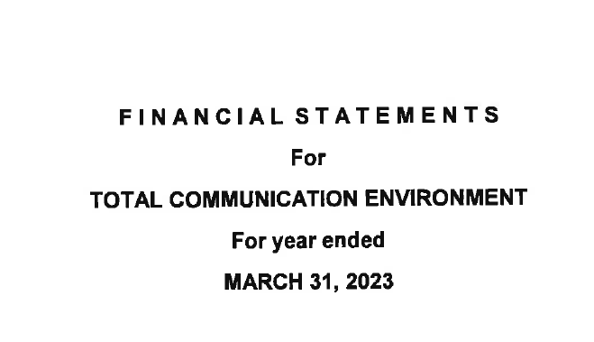

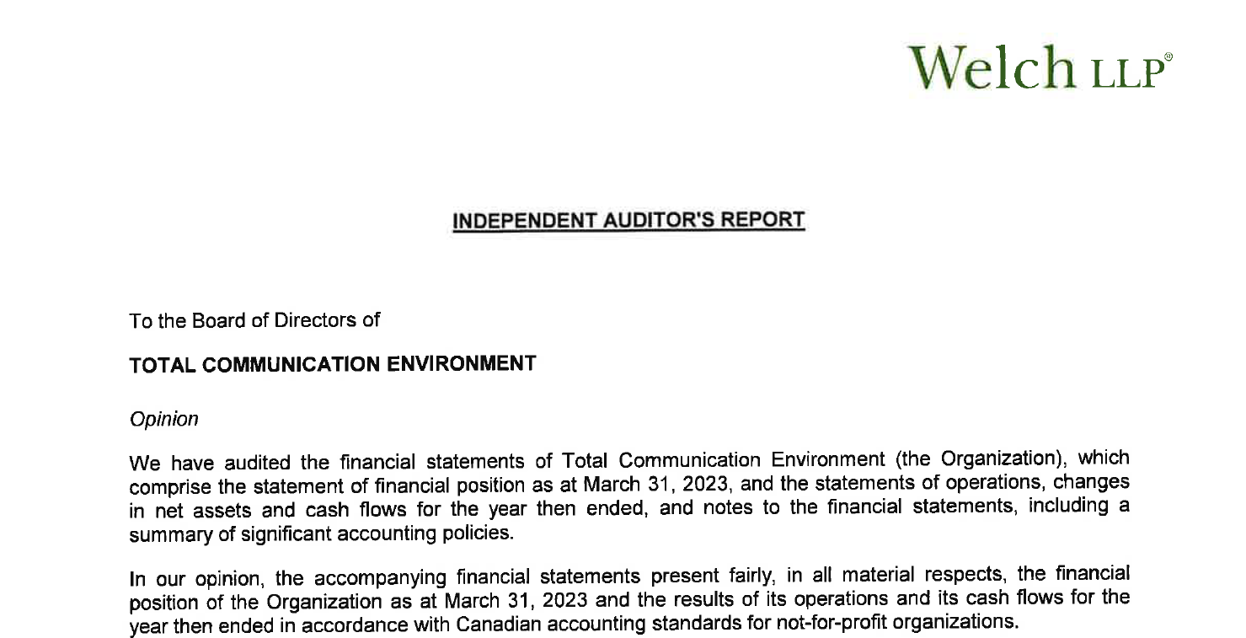

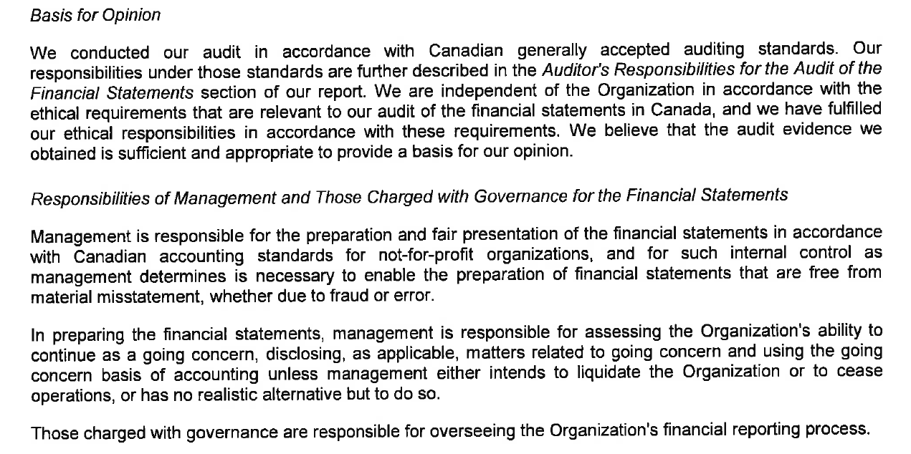

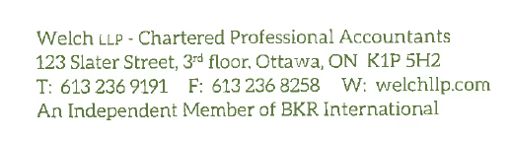

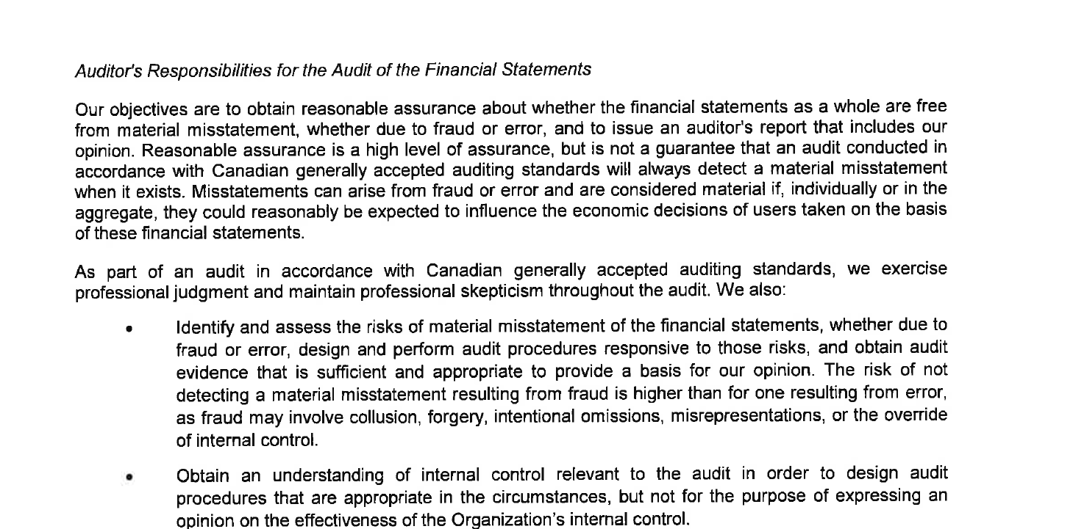
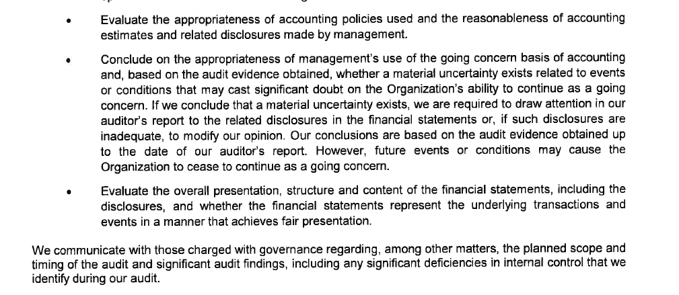

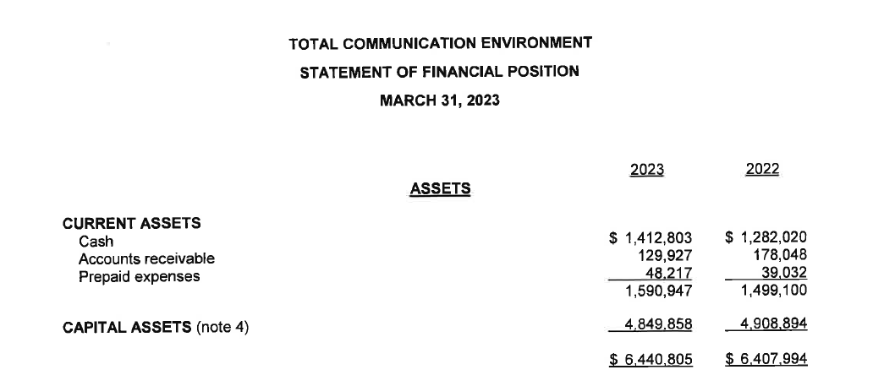
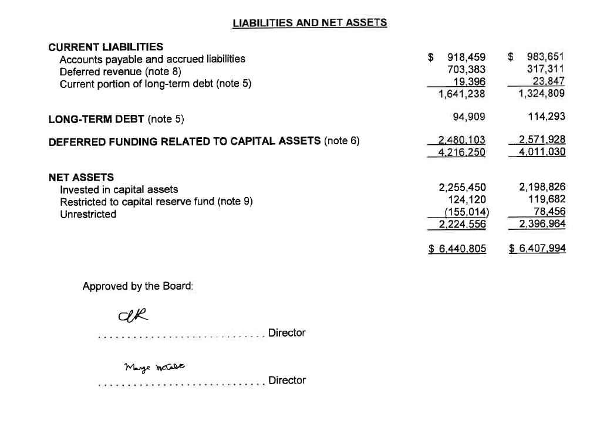 (See Accompanying Notes)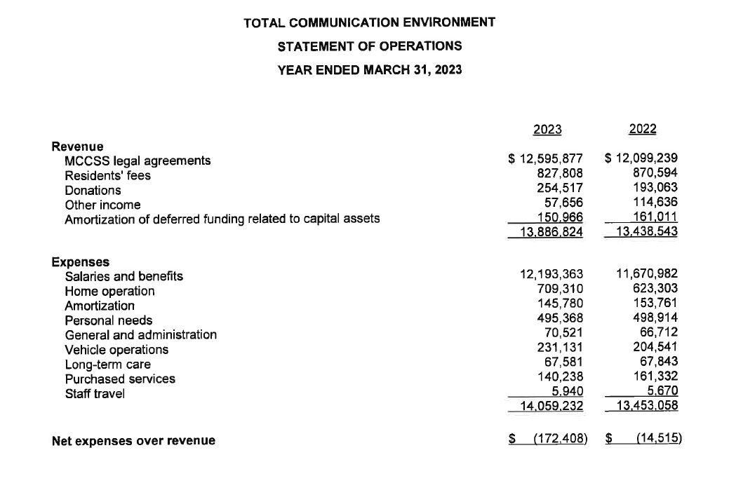

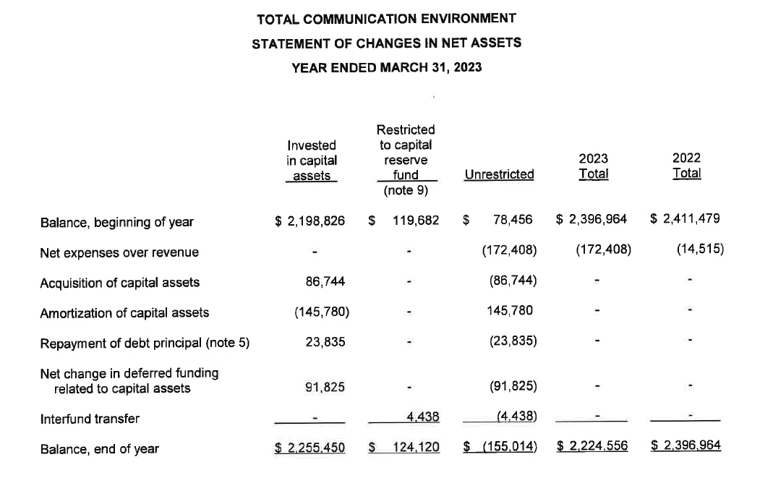

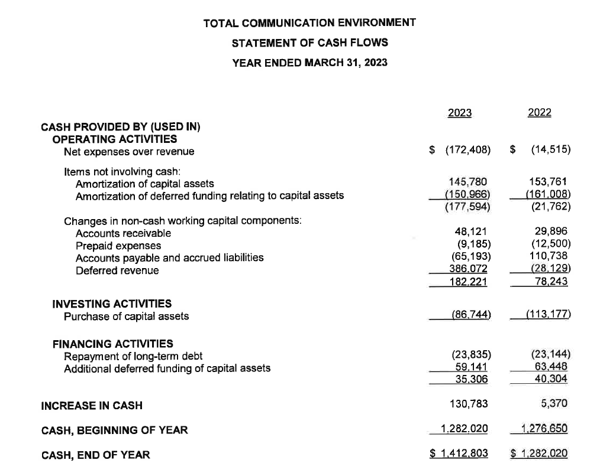

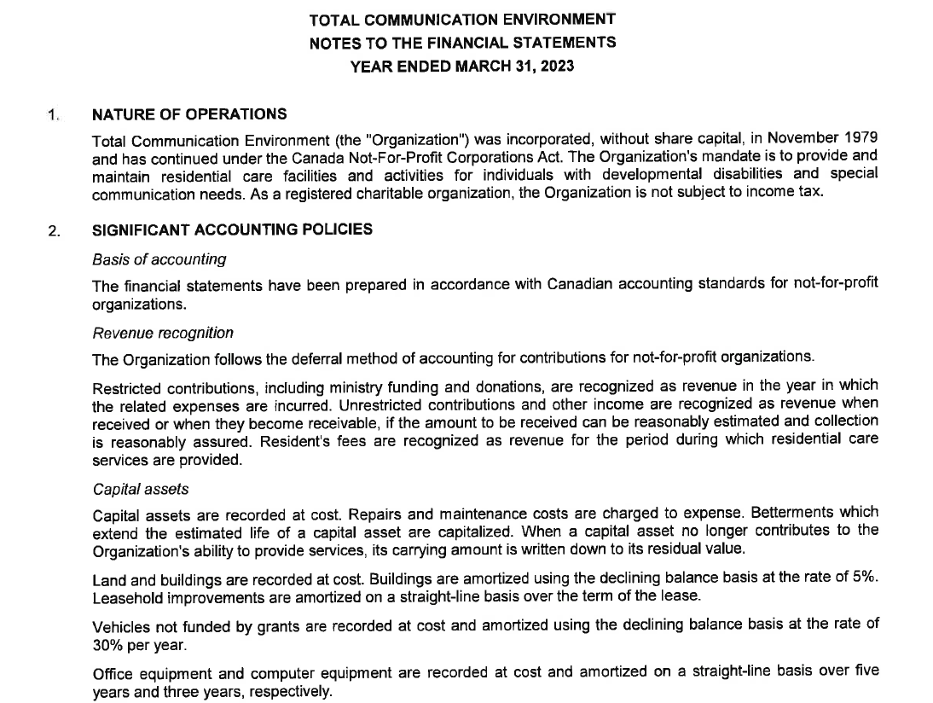

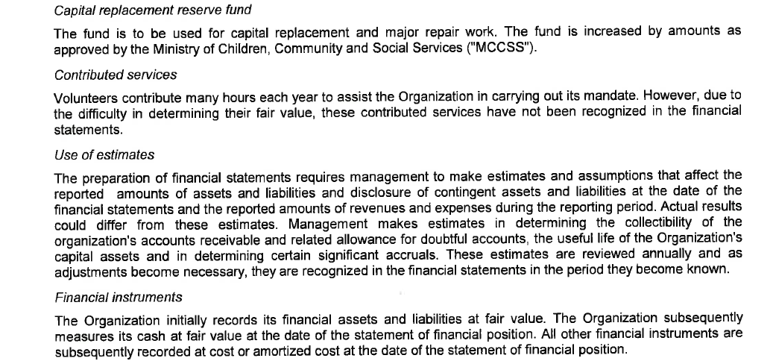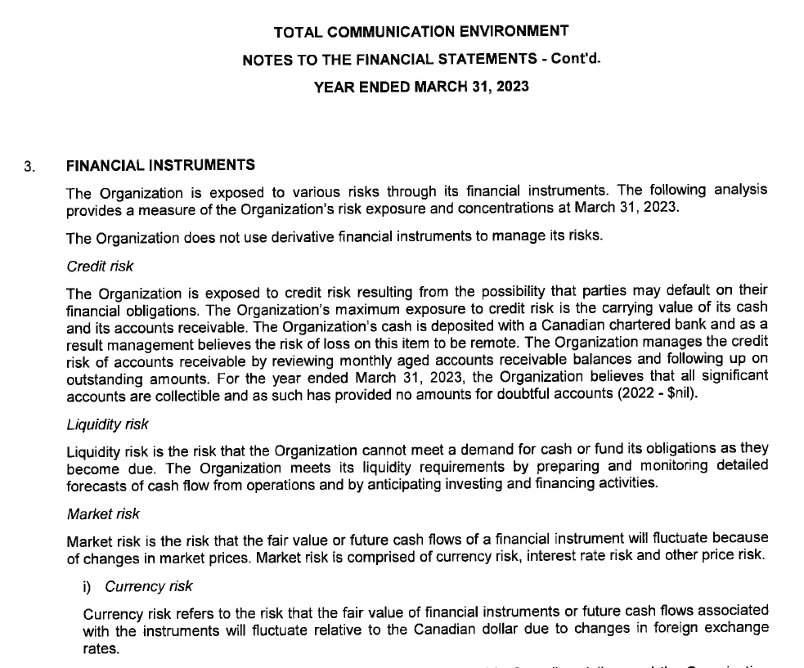
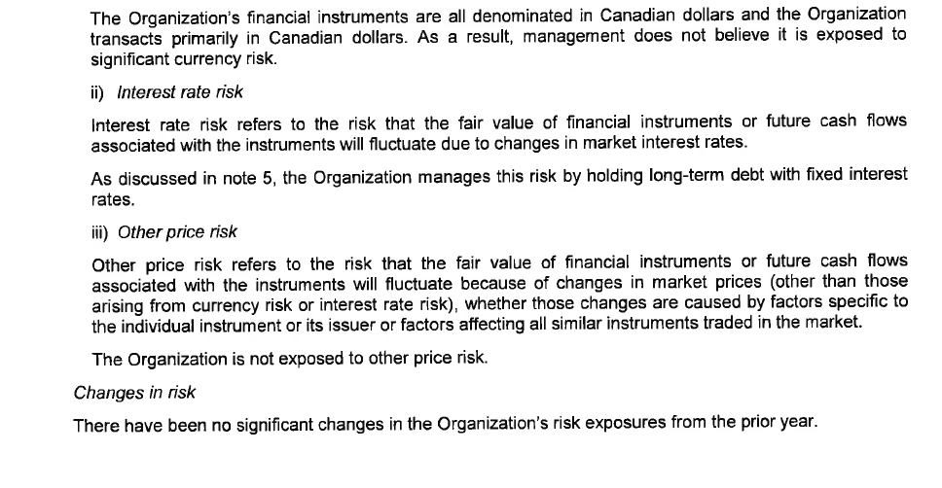

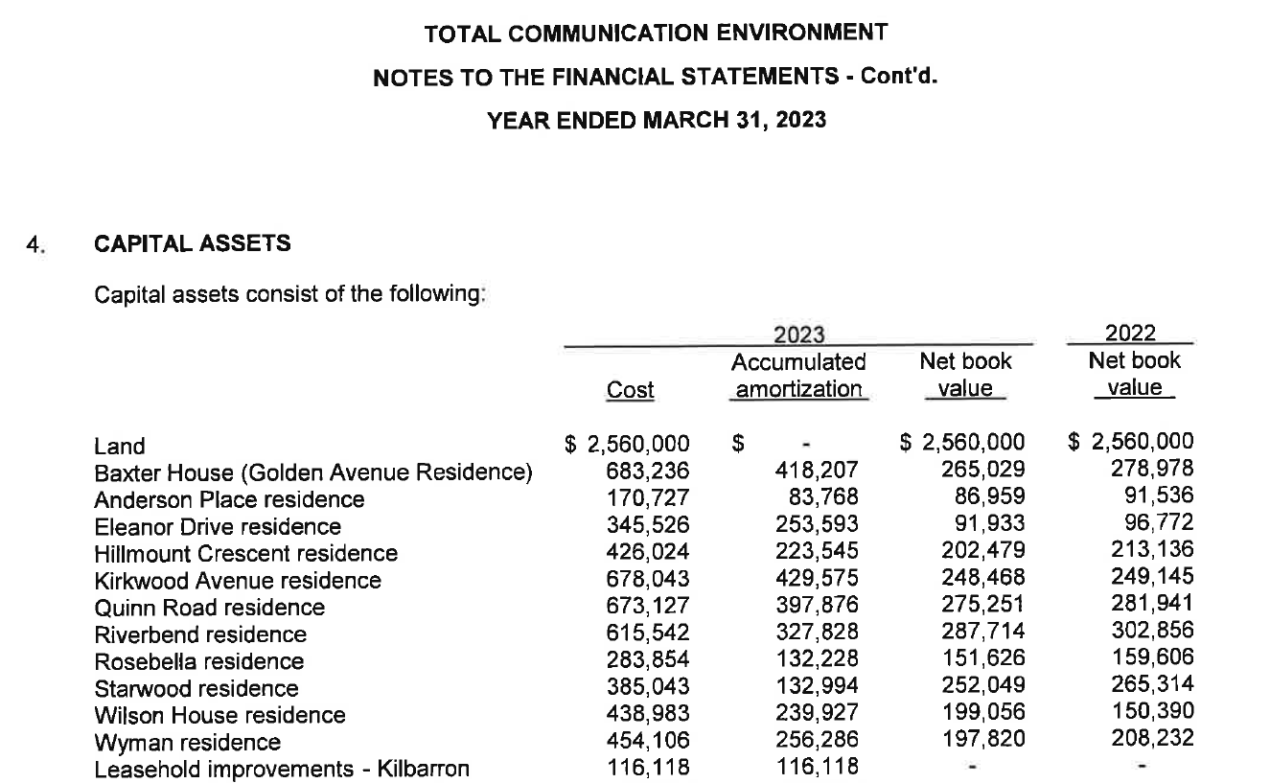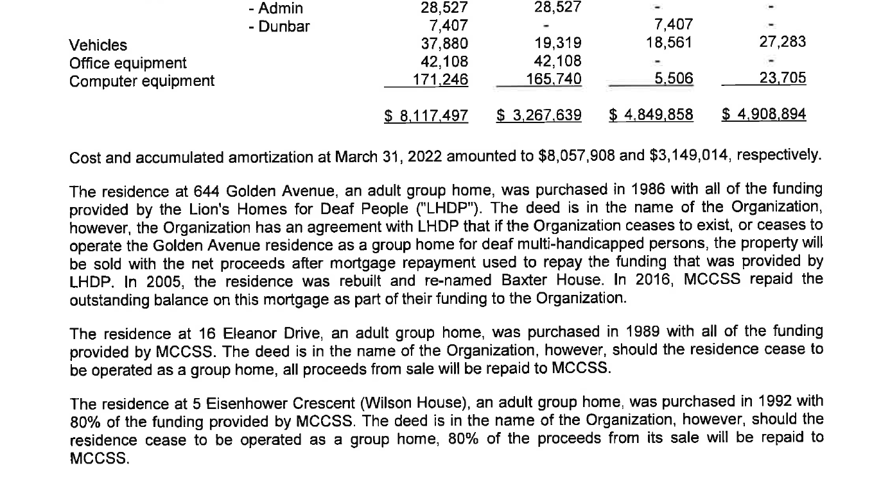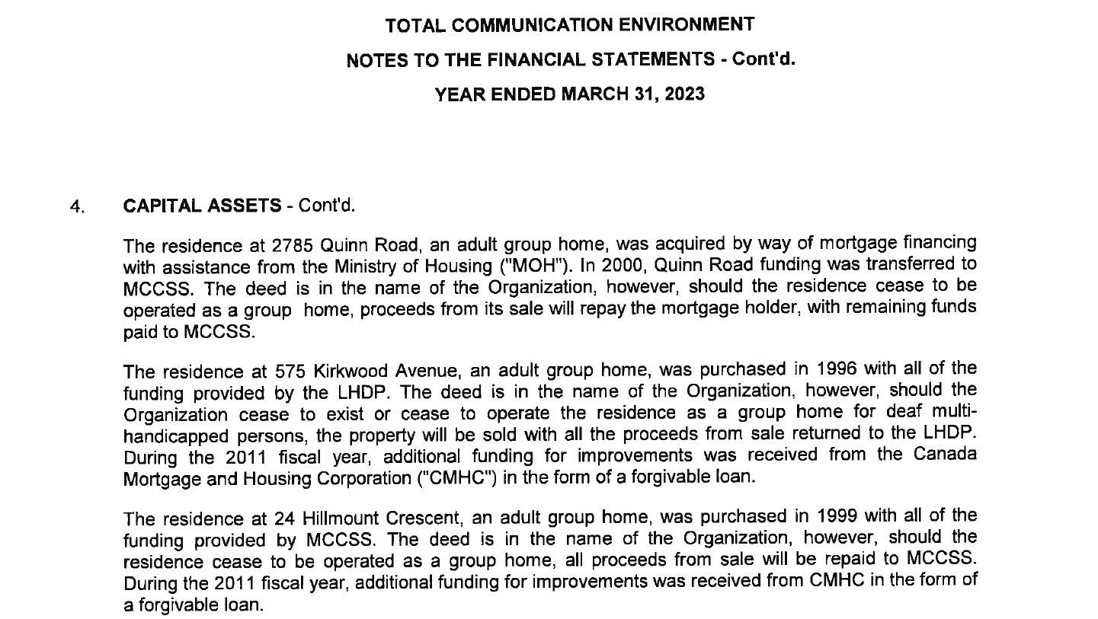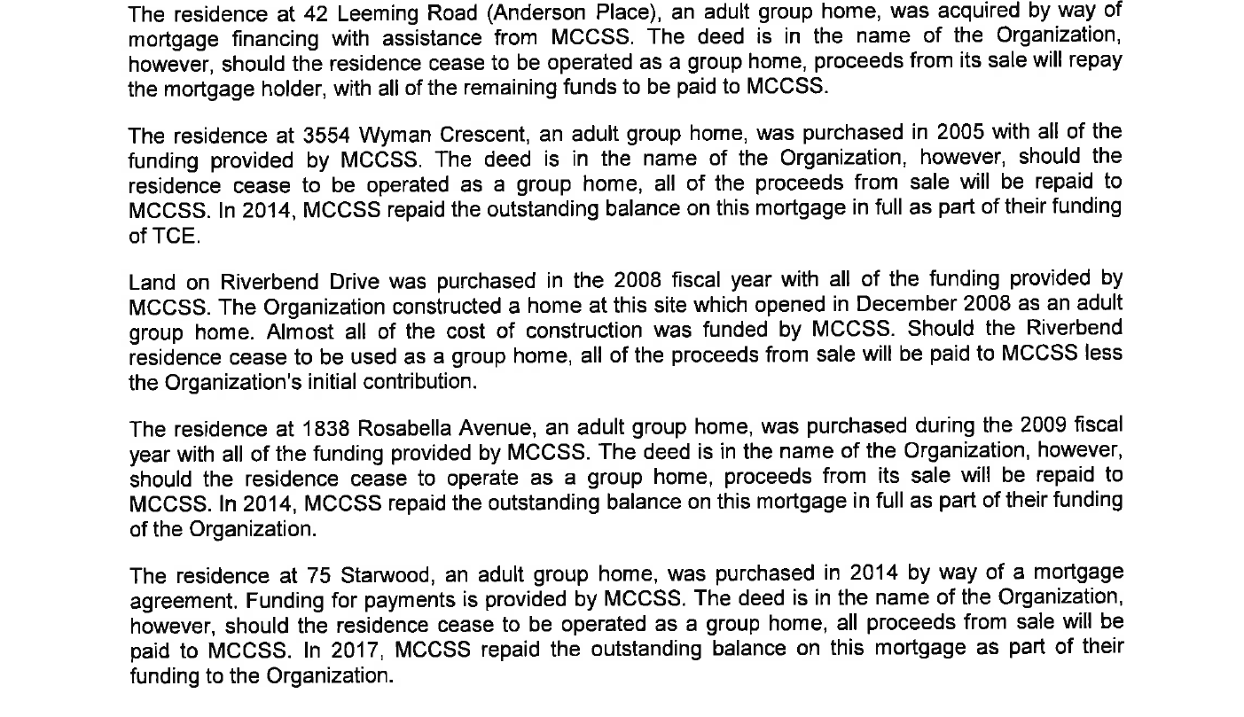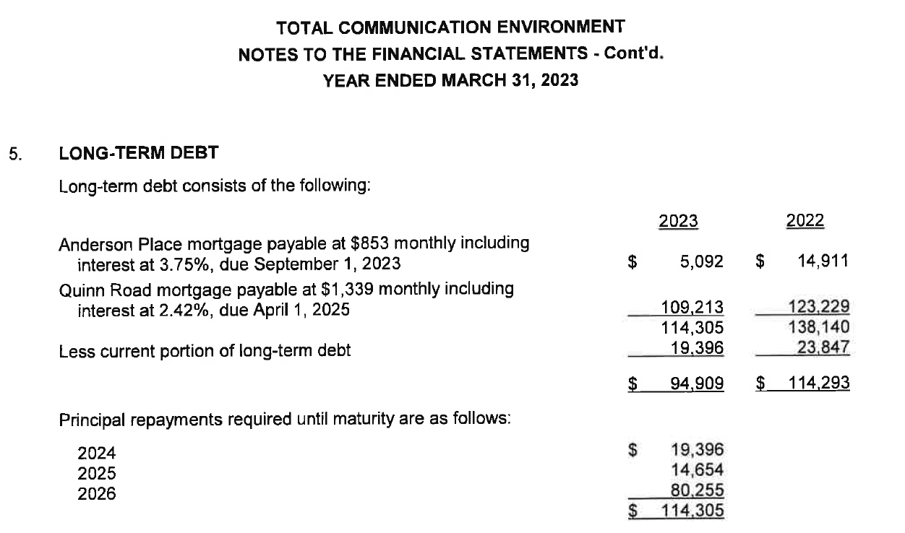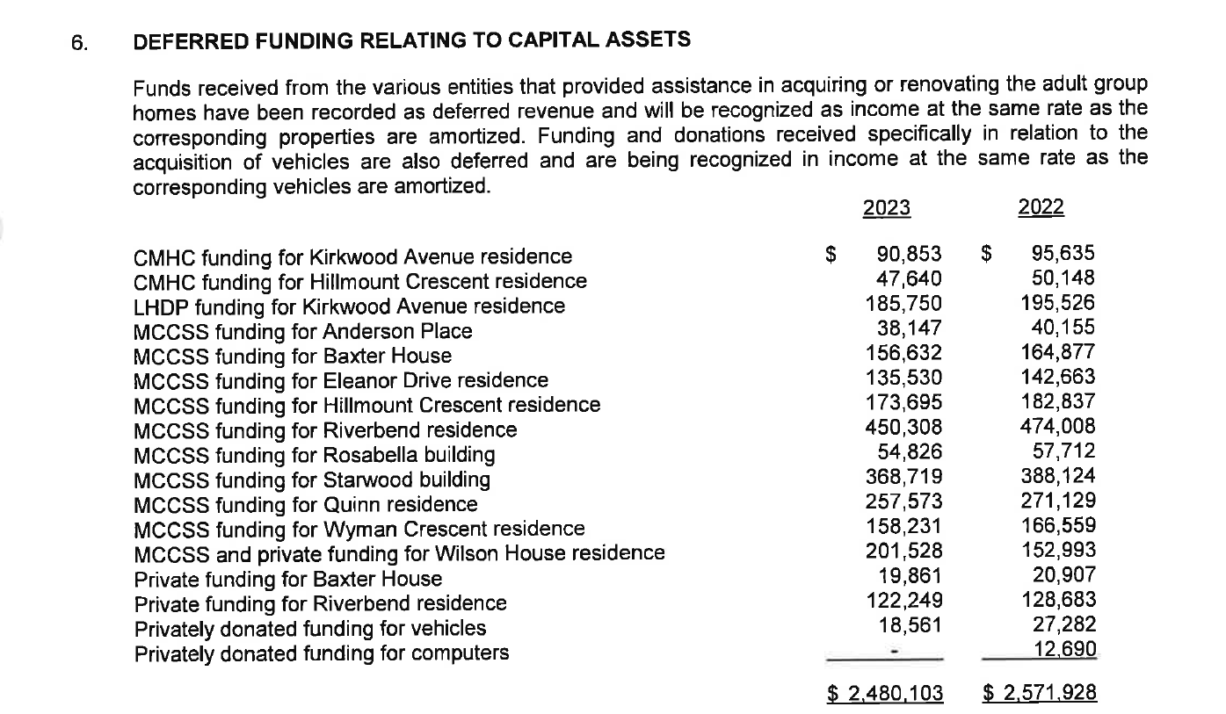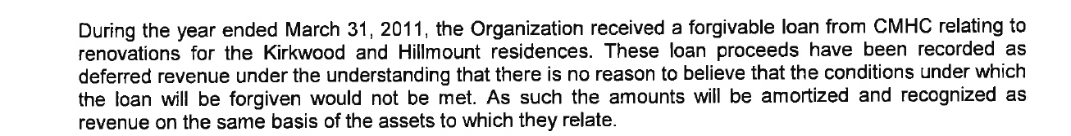

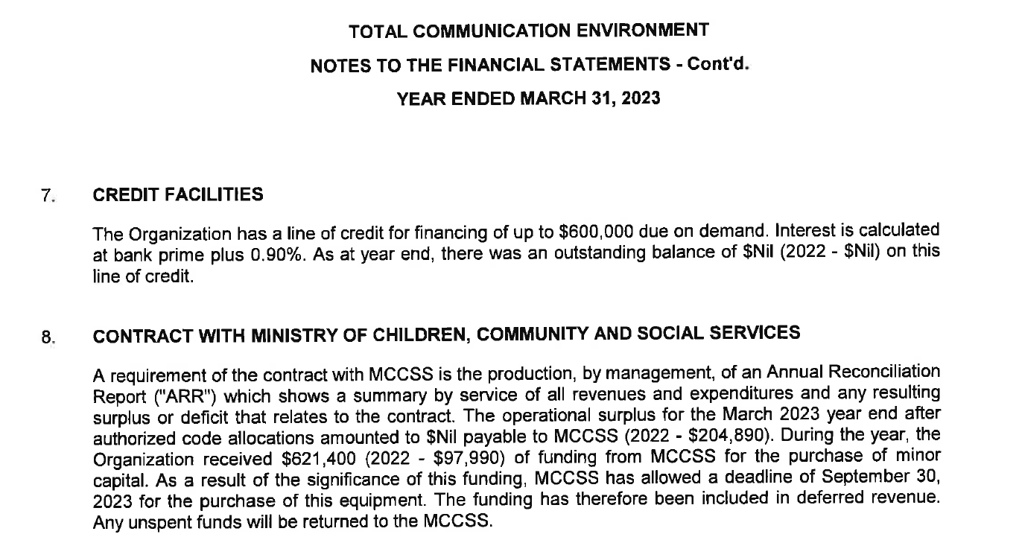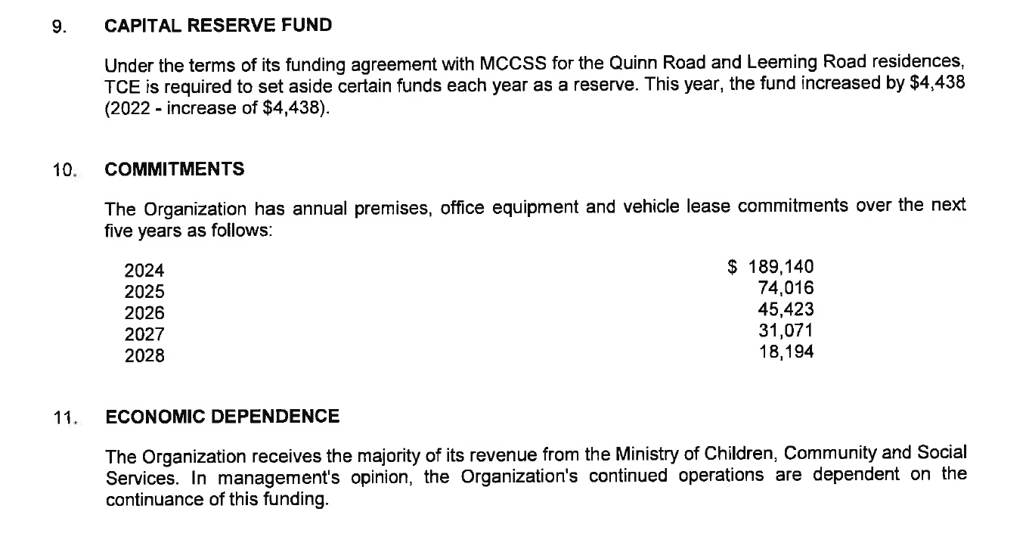

Homes for individuals with multiple disabilities and special communication needs.

190 Colonnade Road, Suite 100, Nepean, ON K2E 7J5
Tel: 613-228-0999 | Fax: 613-228-1402 | TDD 613-228-8669
www.tceottawa.org | BN: 11926 7714 RR0001

